WORKSHEET 3 SQL

**Refer the following ERD and answer all the questions in this worksheet. You have to write the queries using mysql for the required Operation.**

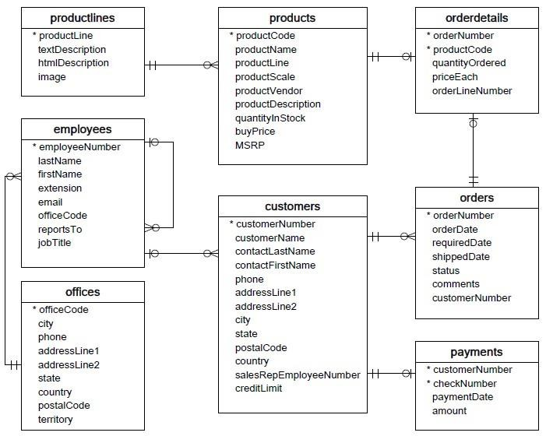

* **Customers**: stores customer’s data.
* **Products**: stores a list of scale model cars.
* **ProductLines**: stores a list of product line categories.
* **Orders**: stores sales orders placed by customers.
* **OrderDetails**: stores sales order line items for each sales order.
* **Payments**: stores payments made by customers based on their accounts.
* **Employees**: stores all employee information as well as the organization structure such as who reports to whom.
* **Offices**: stores sales office data.

1. **Write SQL query to create table Customers.**

# Writing code to create table “Customers” and it’s columns below mentioned

sql_command = """CREATE TABLE Customers(

CustomerNo INTEGER PRIMARY KEY, CustomerName VARCHAR(30),

ContactLastName VARCHAR(15),

ContactFirstName VARCHAR(15),

Phone INTEGER(10),

AddressLine1 VARCHAR(30),

AddressLine2 VARCHAR(30),

City CHAR(20),

State CHAR(20),

PostalCode INTEGER(6),

Country CHAR(10),

SalesRepEmployeeNumber INTEGER (30),

CreditLimit INTEGER(10));"""

# executing code

cursor.execute(sql_command)

# saves all the modifications made since the last commit.

conn.commit()

2. **Write SQL query to create table Orders.**

# Writing code to create table “Orders” and it’s columns below mentioned

sql_command = """CREATE TABLE Orders(

orderNo INTEGER PRIMARY KEY,

orderdate DATE(10),

requireddate DATE(10),

shippeddate DATE(10),

status CHAR(10),

comments VARCHAR(30),

CustomerNo INTEGER (15),

FOREIGN KEY (CustomerNo) REFERENCES Customers (CustomerNo));"""

# executing code

cursor.execute(sql_command)

# saves all the modifications made since the last commit.

conn.commit()

**3. Write SQL query to show all the columns data from the Orders Table.**

sql_command = """SELECT * FROM Orders;"""

select= cursor.execute(sql_command)

for i in select:

print(i)

**4. Write SQL query to show all the comments from the OrdersTable.**

sql_command = """SELECT comments FROM Orders;"""

select= cursor.execute(sql_command)

Parth Makwana (DS0722)

for i in select:

print(i)

**5. Write a SQL query to show orderDate and Total number of orders placed on that date, from**

**Orders table.**

sql_command = """SELECT date(orderdate), COUNT(*) FROM Orders GROUP BY date(orderdate);"""

select= cursor.execute(sql_command)

for i in select:

print(i)

**6. Write a SQL query to show employeNumber, lastName, firstName of all the employees from**

**employees table**.

sql_command = """SELECT EmployeeNo, LastName, FirstName FROM Employees;"""

select= cursor.execute(sql_command)

for i in select:

print(i)

**7. Write a SQL query to show all orderNumber, customerName of the person who placed the**

**respective order.**

sql_command = """SELECT Orders.orderNo, Customers.CustomerName FROM Orders, Customers

WHERE Orders.CustomerNo = Customers.CustomerNo;"""

select= cursor.execute(sql_command)

for i in select:

print(i)

**8. Write a SQL query to show name of all the customers in one column and salerepemployee name**

**inanother column**

sql_command = """SELECT Customers.CustomerName, Employees.FirstName || ' ' || LastName AS

FullName FROM Customers, Employees WHERE Customers.SalesRepEmployeeNumber =

Employees.EmployeeNo;"""

select= cursor.execute(sql_command)

for i in select:

print(i)

**9. Write a SQL query to show Date in one column and total payment amount of the payments made**

**on that date from the payments table.**

sql_command = """SELECT date(PaymentDate), SUM(Amount) FROM Payments GROUP BY

date(PaymentDate);"""

select= cursor.execute(sql_command)

for i in select:

print(i)

**10. Write a SQL query to show all the products productName, MSRP, productDescription from the**

**products table.**

sql_command = """SELECT ProductName, MSRP, ProductDescription FROM Products;"""

select= cursor.execute(sql_command)

for i in select:

print(i)

Parth Makwana (DS0722)

**11. Write a SQL query to print the productName, productDescription of the most ordered product.**

sql_command = """SELECT Products.ProductName, Products.ProductDescription,

SUM(OrderDetails.QuantityOrdered) AS QuantityOrdered FROM Products INNER JOIN OrderDetails ON

OrderDetails.ProductCode = Products.ProductCode GROUP BY OrderDetails.QuantityOrdered ;"""

select= cursor.execute(sql_command)

for i in select:

print(i)

**12. Write a SQL query to print the city name where maximum number of orders were placed.**

sql_command = """SELECT Customers.City, SUM(OrderDetails.QuantityOrdered) AS QuantityOrdered

FROM Customers INNER JOIN OrderDetails, Orders ON Customers.CustomerNo = Orders.CustomerNo

and Orders.orderNo = OrderDetails.orderNo GROUP BY OrderDetails.QuantityOrdered ;"""

select= cursor.execute(sql_command)

for i in select:

print(i)

**13. Write a SQL query to get the name of the state having maximum number of customers**.

sql_command = """SELECT State, COUNT(*) AS Max_Customer FROM Customers

GROUP BY State ORDER BY COUNT(*) DESC;"""

select= cursor.execute(sql_command)

for i in select:

print(i)

**14. Write a SQL query to print the employee number in one column and Full name of the employee**

**in the second column for all the employees.**

sql_command = """SELECT EmployeeNo, FirstName || ' ' || LastName AS FullName

FROM Employees ;"""

select= cursor.execute(sql_command)

for i in select:

print(i)

**15. Write a SQL query to print the orderNumber, customer Name and total amount paid by the**

**customer for that order (quantityOrdered × priceEach)**

sql_command = """SELECT OrderDetails.orderNo, Customers.CustomerName,

(OrderDetails.QuantityOrdered * OrderDetails.PriceEach) AS Amount FROM OrderDetails INNER JOIN

Customers, Orders ON Customers.CustomerNo = Orders.CustomerNo and OrderDetails.orderNo =

Orders.orderNo;"""

select= cursor.execute(sql_command)

for i in select:

* 1. Write a SQL query to show Date in one column and total payment amount of the payments made on that date from the **payments** table.
  2. Write a SQL query to show all the products productName, MSRP, productDescription from the **products**

table.

* 1. Write a SQL query to print the productName, productDescription of the most ordered product.
  2. Write a SQL query to print the city name where maximum number of orders were placed.
  3. Write a SQL query to get the name of the state having maximum number of customers.
  4. Write a SQL query to print the employee number in one column and Full name of the employee in the second column for all the employees.
  5. Write a SQL query to print the orderNumber, customer Name and total amount paid by the customer for that order (quantityOrdered × priceEach).

